**Amazon E-Commerce Project Documentation**

**Vikas Upadhyay**

**Observations and insights for Objective and Subjective questions:**

**Objective Question:**

1. **What is the total number of attributes in the customer table?**

* The total number of attributes in the customers table is the number of columns it has.
* The customers table has **3 attributes** i.e. (CustomerID, Customer Age, Customer Gender)

1. **How will you get the “Customer’s” ages in the “Order” tables according to customer IDs?**

* To get the **Customer’s Ages** in the **Orders** table according to **Customer IDs**, you need to establish a relationship between the customers table and the orders table, then create a calculated column or use the related field in your visuals.
* Establish a Relationship Between Tables by Drag and drop CustomerID from the customers table onto CustomerID in the orders table.
* We can now use the Customer Age field in the customers table to interact with the orders table by creating a calculated column using a DAX formula.
* **Customers Age** = LOOKUPVALUE(Customers[Customer Age],Customers[CustomerID],Orders[CustomerID]

1. I**n analyzing the dataset with Power BI, ensure data cleaning to address inconsistencies and missing values before further analysis.**

* By the use of Power Query Editor, we clean the data for better analysis. First, we transform the data into power query editor and start cleaning our data.
* In data cleaning, I make sure that all the columns do not have any empty rows. After removing the empty rows, I changed the data type of order date and delivery date column to “Date” type.
* In the reason column, there were some empty rows without any reason for return of the product and for delivered products. So, I replaced those rows with “Unknown reason” for empty rows which have returned products and “Not Applicable” reason for empty rows whose products were delivered.
* By looking at the data set, there were 5 extra columns which are not necessary, so I removed them from the data set.

1. **How can we calculate the total revenue generated by all the sales?**

* To calculate the Total Revenue, I have created a New Measure to sum the Sale Price Column. The DAX formula is **Total Revenue** = SUM(Orders[Sale Price]) which gives the answer Total Revenue of **107.23M.**

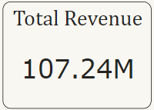

1. **What is the total number of unique customers who made purchases each year? Is there any increase in the number over the years?**

* Total unique customers are **0.11M** who made purchases. The approach is by creating a visual card and counting the Customer ID to get the values.

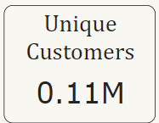

* In the below Bar chart, we can see how many customers made purchases each year. In x-axis Count of Customer ID and in y-axis Year. As we can see in the chart, there is an increase trend over the years.

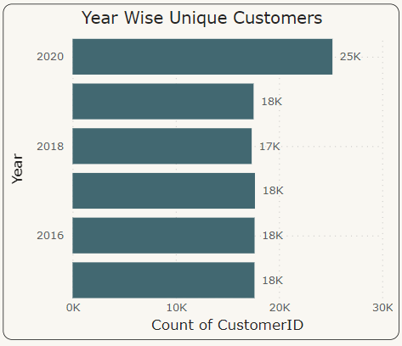

1. **How can we determine the total number of unique products available in the company?**

* There are a total of 44 unique products available in the company. To show this value, I used card visual and by the Count of product column in the field we can determine the total number of unique products.

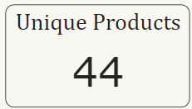

1. **What is the average number of days it takes for products to be delivered, get the metric for only the delivered orders.**

* The average delivery time for a product to be delivered for “Delivered Products” is 9.41 days. The DAX Functions which I used are **Delivered Orders = CALCULATE(SUM(Orders[Delivery Days]), Orders[Status] = "Delivered") and Average Delivery Time for Delivered Orders = AVERAGEX(Orders, [Delivered Orders]).**
* By using the card visual I presented the Average Delivery Time for Delivered orders inserting calculated column Average Delivery Time for Delivered Orders.

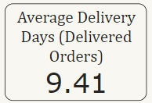

1. **Which products, categories, and subcategories are the most popular?**

* In the below visual, we can see the most popular Products, Product Categories and Sub Categories by Highest Sales. By using the Table chart and Filter Pane obtained the results. In the Filter pane, I filtered the product with Top 3 in Sum of Order Quantity.

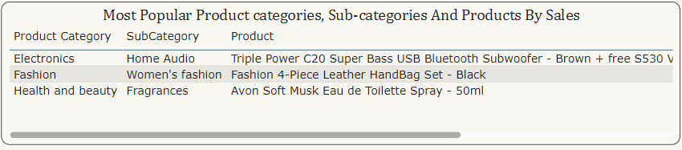

1. **Which products have seen an increase or decrease in sales over the year?**

* To calculate the Sales increase or decrease by year, first I calculated Previous year sales with the DAX formula
* **Previous Year's Sales** = CALCULATE( [Total Sales],Orders[Year] = MAX(Orders[Year]) - 1 && Orders[Month] = MAX(Orders[Month]))

and Calculated the Sales Increase/Decrease with **Sales increase/decrease =** [Total Sales] - [Previous Year’s Sales].

* I have used Area chart to show Sales Increase/Decrease for each product over the period of 6 years.

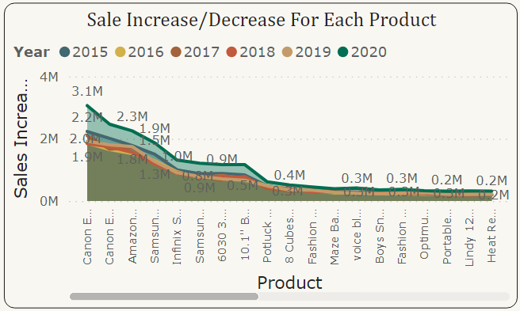

1. **While modeling the data relationships, what will be the type of relationship between the customer ID of Orders and customer tables?**

* The type of relationship between the CustomerID in the orders table and the customers table in data modeling will be a Many-to-One relationship.
* Each order in the orders table is associated with exactly one customer in the customers table via CustomerID.
* Multiple orders in the orders table can belong to the same CustomerID, but each CustomerID in the customers table is unique.
* Many rows in the orders table are associated with one row in the customers table.

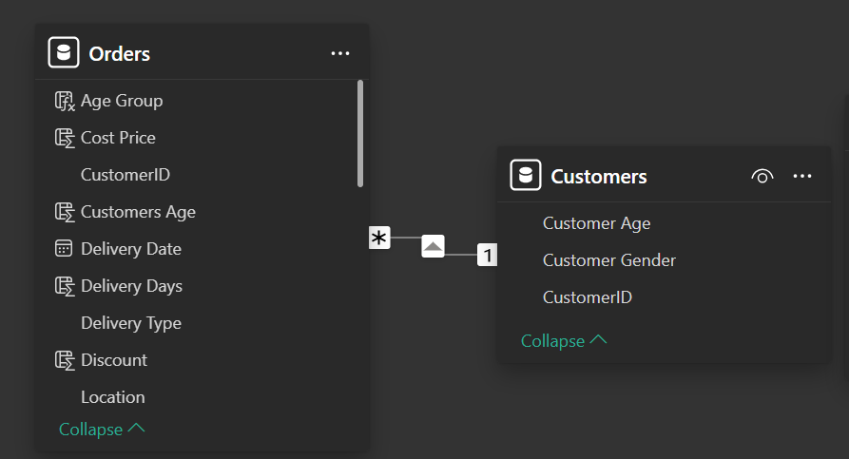

* When analyzing from the **Orders** table, each record (order) belongs to a single customer. This creates a **Many-to-One** mapping from orders to customers.

1. **How have you handled the null values in the data?**

* Handling null values in data is crucial to ensure the quality and reliability of the dataset:
* Used Power Query Transformations to remove null values from OrderDate, Delivery Date (drop null rows as dates are critical), Customer Gender, Delivery Type and Product Category.
* Drop rows with null CustomerID.
* **Reason:** Replace null values with **"Not Applicable"** or **"Unknown Reason"** since it’s textual. Reason Clean = IF(Orders[Status]="Delivered","Not Applicable",IF(ISBLANK('Orders'[Reason]),"Unknown Reason",'Orders'[Reason])).

1. **Were there any data format issues in the data, and if there were/are how you would handle them?**

* No, there were no data format issues in the data.
* If we were to handle them, we would apply following steps:
* **Inspect Data**: Use Column Profile to check for nulls and inconsistencies.
* **Assign Data Types**: Correct types for each column (e.g., Date, Text, Number).
* **Replace or Remove Nulls**: Use defaults or remove invalid rows/values.
* **Standardize Text**: Apply transformations like trimming, replacing, or formatting.
* **Load Clean Data**: After all issues are resolved, load the cleaned data into Power BI.

1. **When we add a column in Power Query what’s the code that comes in M language in the formula bar? What do you know about M-query?**

* When adding a new column in Power Query, the formula bar typically shows M code like this:
* = Table.AddColumn(Source, "NewColumn", each [ExistingColumn] * 2)
* This example adds a column named **"NewColumn"**, where each value is calculated as **ExistingColumn** multiplied by 2.
* What is M Query?
* M Query (also known as Power Query Formula Language) is a functional language used in Power Query to transform, manipulate, and clean data. It allows users to define step-by-step transformations in Power BI, Excel, and other Microsoft products. M is used to:
* Filter, aggregate, and merge data.
* Perform custom calculations and transformations.
* Define parameters and handle complex data scenarios.

1. **Identify the top 5 most valuable customers using a composite score that combines three key metrics: (SQL)**
2. Total Revenue (50% weight): The total amount of money spent by the customer.
3. Order Frequency (30% weight): The number of orders placed by the customer, indicating their loyalty and engagement.
4. Average Order Value (20% weight): The average value of each order placed by the customer, reflecting the typical transaction size.

* **Query:**

WITH CustomerMetrics AS (

SELECT

o.CustomerID,

SUM(o.SalePrice) AS TotalRevenue,

COUNT(o.OrderID) AS OrderFrequency,

AVG(o.SalePrice) AS AvgOrderValue

FROM

orders o

GROUP BY

o.CustomerID

),

NormalizedMetrics AS (

SELECT

cm.CustomerID,

cm.TotalRevenue,

cm.OrderFrequency,

cm.AvgOrderValue,

cm.TotalRevenue / (SELECT MAX(TotalRevenue) FROM CustomerMetrics) AS NormalizedRevenue,

cm.OrderFrequency / (SELECT MAX(OrderFrequency) FROM CustomerMetrics) AS NormalizedFrequency,

cm.AvgOrderValue / (SELECT MAX(AvgOrderValue) FROM CustomerMetrics) AS NormalizedValue

FROM

CustomerMetrics cm

),

CompositeScores AS (

SELECT

nm.CustomerID,

(nm.NormalizedRevenue * 0.50) +

(nm.NormalizedFrequency * 0.30) +

(nm.NormalizedValue * 0.20) AS CompositeScore

FROM

NormalizedMetrics nm

)

SELECT

cs.CustomerID,

cs.CompositeScore

FROM

CompositeScores cs

ORDER BY

cs.CompositeScore DESC

LIMIT 5;

* **Output:**

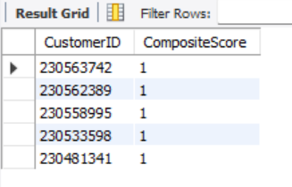

1. **Calculate the month-over-month growth rate in total revenue across the entire dataset. (SQL)**

* **Query:**

WITH MonthlyRevenue AS (

SELECT

DATE_FORMAT(str_to_date(OrderDate,'%d/%m/%Y'), '%Y-%m') AS YearMonth,

SUM(SalePrice) AS TotalRevenue

FROM

orders

GROUP BY

YearMonth

ORDER BY

YearMonth

),

RevenueGrowth AS (

SELECT

mr.YearMonth,

mr.TotalRevenue,

LAG(mr.TotalRevenue) OVER (ORDER BY mr.YearMonth) AS PreviousMonthRevenue,

CASE

WHEN LAG(mr.TotalRevenue) OVER (ORDER BY mr.YearMonth) IS NOT NULL THEN

((mr.TotalRevenue - LAG(mr.TotalRevenue) OVER (ORDER BY mr.YearMonth)) /

LAG(mr.TotalRevenue) OVER (ORDER BY mr.YearMonth)) * 100

ELSE

NULL

END AS MoMGrowthRate

FROM

MonthlyRevenue mr

)

SELECT

ROUND(YearMonth,2) AS YearMonth,

ROUND(TotalRevenue,2) AS TotalRevenue,

ROUND(PreviousMonthRevenue,2) AS PreviousMonthRevenue,

ROUND(MoMGrowthRate,2) AS MoMGrowthRate

FROM

RevenueGrowth

ORDER BY

YearMonth;

* **Output:**

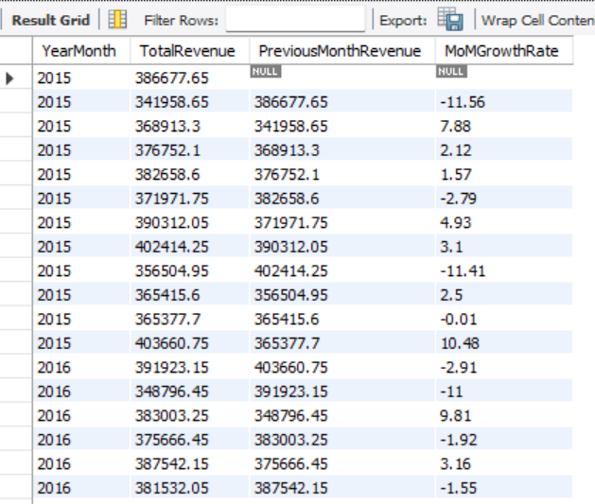

1. **Calculate the rolling 3-month average revenue for each product category. (SQL)**

* **Query:**

WITH MonthlyCategoryRevenue AS (

SELECT

DATE_FORMAT(str_to_date(OrderDate,'%d/%m/%Y'), '%Y-%m') AS YearMonth,

ProductCategory,

SUM(SalePrice) AS TotalRevenue

FROM

orders

GROUP BY

YearMonth, ProductCategory

ORDER BY

YearMonth

)

SELECT

mcr.YearMonth,

mcr.ProductCategory,

mcr.TotalRevenue,

AVG(mcr.TotalRevenue) OVER (

PARTITION BY mcr.ProductCategory

ORDER BY mcr.YearMonth

ROWS 2 PRECEDING

) AS Rolling3MonthAvgRevenue

FROM

MonthlyCategoryRevenue mcr

ORDER BY

mcr.ProductCategory, mcr.YearMonth;

* **Output:**

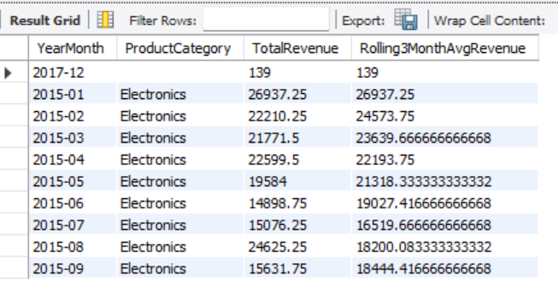

1. **Update the orders table to apply a 15% discount on the `Sale Price` for orders placed by customers who have made at least 10 orders. (SQL)**

* **Query:**

SET SQL_SAFE_UPDATES = 0;

WITH FrequentCustomers AS (

SELECT

CustomerID

FROM

orders

GROUP BY

CustomerID

HAVING

COUNT(OrderID) >= 10

)

UPDATE orders

SET SalePrice = SalePrice * 0.85

WHERE CustomerID IN (SELECT CustomerID FROM FrequentCustomers);

SET SQL_SAFE_UPDATES = 1;

1. **Calculate the average number of days between consecutive orders for customers who have placed at least five orders. (SQL)**

* **Query:**

WITH EligibleCustomers AS (

SELECT

CustomerID

FROM

orders

GROUP BY

CustomerID

HAVING

COUNT(OrderID) >= 5

),

OrderIntervals AS (

SELECT

o.CustomerID,

o.OrderDate,

DATEDIFF(o.OrderDate, LAG(o.OrderDate) OVER (

PARTITION BY o.CustomerID ORDER BY o.OrderDate

)) AS DaysBetweenOrders

FROM

orders o

WHERE

o.CustomerID IN (SELECT CustomerID FROM EligibleCustomers)

),

AverageDaysPerCustomer AS (

SELECT

CustomerID,

AVG(DaysBetweenOrders) AS AvgDaysBetweenOrders

FROM

OrderIntervals

WHERE

DaysBetweenOrders IS NOT NULL

GROUP BY

CustomerID

)

SELECT

AVG(AvgDaysBetweenOrders) AS OverallAvgDaysBetweenOrders

FROM

AverageDaysPerCustomer;

* **Output:**

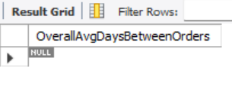

1. **Identify customers who have generated revenue that is more than 30% higher than the average revenue per customer. (SQL)**

* **Query:**

WITH CustomerRevenue AS (

SELECT

CustomerID,

SUM(SalePrice) AS TotalRevenue

FROM

orders

GROUP BY

CustomerID

),

AverageRevenue AS (

SELECT

AVG(TotalRevenue) AS AvgRevenue

FROM

CustomerRevenue

)

SELECT

cr.CustomerID,

ROUND(cr.TotalRevenue,2) AS TotalRevenue,

ROUND(ar.AvgRevenue,2) AS AvgRevenue,

ROUND((cr.TotalRevenue - ar.AvgRevenue),2) AS ExcessRevenue

FROM

CustomerRevenue cr

CROSS JOIN

AverageRevenue ar

WHERE

cr.TotalRevenue > ar.AvgRevenue * 1.3

ORDER BY

cr.TotalRevenue DESC;

* **Output:**

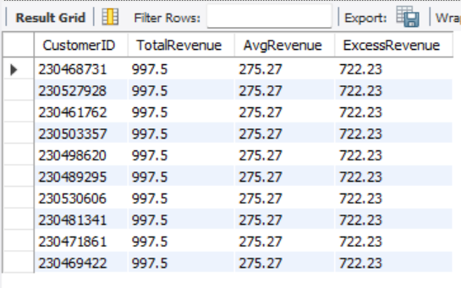

1. **Determine the top 3 product categories that have shown the highest increase in sales over the past year compared to the previous year. (SQL)**

* **Query:**

WITH YearlyCategorySales AS (

SELECT

DATE_FORMAT(str_to_date(OrderDate,'%d/%m/%Y'), '%Y') AS SalesYear,

ProductCategory,

SUM(SalePrice) AS TotalSales

FROM

orders

GROUP BY

SalesYear, ProductCategory

),

CategorySalesGrowth AS (

SELECT

ycs.ProductCategory,

ycs.SalesYear,

ycs.TotalSales,

LAG(ycs.TotalSales) OVER (PARTITION BY ycs.ProductCategory ORDER BY ycs.SalesYear) AS PreviousYearSales,

(ycs.TotalSales - LAG(ycs.TotalSales) OVER (PARTITION BY ycs.ProductCategory ORDER BY ycs.SalesYear)) AS SalesIncrease

FROM

YearlyCategorySales ycs

),

RankedCategories AS (

SELECT

csg.ProductCategory,

csg.SalesYear,

csg.TotalSales,

csg.PreviousYearSales,

csg.SalesIncrease,

DENSE_RANK() OVER (ORDER BY csg.SalesIncrease DESC) AS `Rank`

FROM

CategorySalesGrowth csg

WHERE

csg.SalesYear = (SELECT MAX(SalesYear) FROM orders)

)

SELECT

ProductCategory,

SalesYear,

ROUND(TotalSales,2) AS TotalSales,

ROUND(PreviousYearSales,2) AS PreviousYearSales,

ROUND(SalesIncrease,2) AS SalesIncrease

FROM

RankedCategories

WHERE

`Rank` <= 3

ORDER BY

SalesIncrease DESC;

* **Output:**

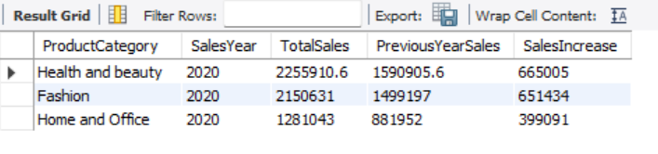

* **Subjective Questions:**

1. **Explain the revenue breakdown by year and by-product. Evaluate how different products contribute to annual revenue and come up with suggestions to increase the sales of the low-selling items.**

* 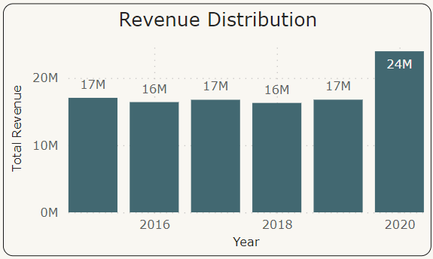

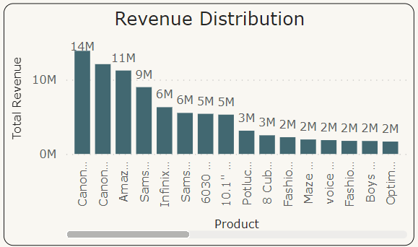

* In the first column chart, we can see how revenue break down by each year. In the second column chart, it is noticeable how different products contribute to annual.
* To increase the sales of low-selling items we can use some strategies like Selling in a bundle of low-priced items to increase their revenue, marketing promotions for low selling items, giving more points on the purchase of that product etc.

1. **How many products were returned? Use a DAX function to get this metric. Examine the possible reasons for returns and consider how this metric could indicate improvements in product descriptions or quality control.**

* The total number of returns is 31K with 44 unique products.

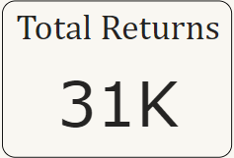

* The possible reasons for the returns are:
* Defective items - Delivering the defective items makes customers lose interest in the quality of the brand. So, make sure before going for a package the quality of the product needs to be checked.
* Delivery Missing item/part - Product description should mention clearly all the components and should provide a checklist of what's included.
* Onsite Description Mismatch - Product description should match with the products that are going to deliver otherwise it leads to customer dissatisfaction. Make sure to regularly update the description in the online platform.
* Product not fitting expectations - Make sure the size chart provided in the product description shows multiple options for customers to choose perfect size.
* Delivery wrong item - Have multiple checkpoints to see if the right product is going for a package before delivering the product.
* Unknown Reasons - There are some unknown reasons for the product to be returned. Make sure while collecting the return packages take note of the reasons for return for better understanding.

1. **Whenever a customer goes to Amazon, they’ll filter the most rated products to buy the better category. Can you verify this using any visualization or table that the ratings of products impact their sales value?**

* From the given data, it is evident that products with lower ratings have higher sales. This could be for several reasons like immediate need of the product, low price of the product, availability of the specific product in the platform, specific brand etc.

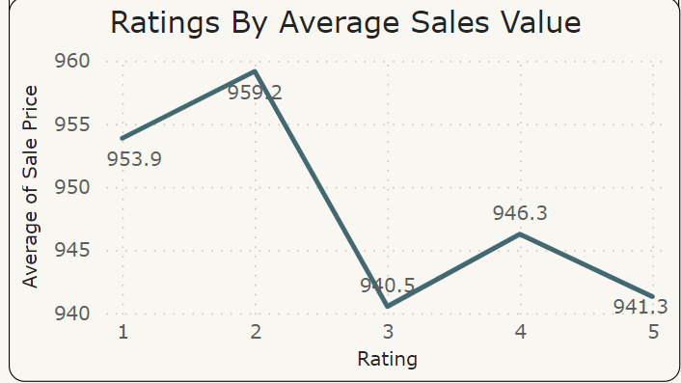

1. **Investigate how revenue distribution varies across different locations. Explore which geographical areas contribute most to sales and consider the strategic implications for regional marketing and distribution efforts. How might location-based trends inform the company's market segmentation and resource allocation approach?**

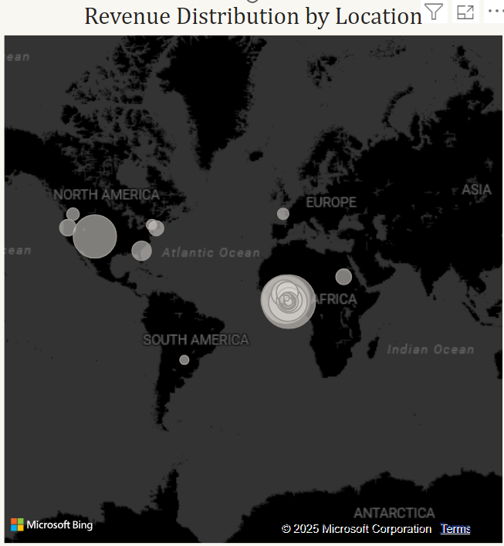

* From the above Map chart, we can see the revenue distribution across different locations. As we can see North America and African regions contribute most to sales, so tailor the marketing strategies accordingly. For example, North American regions, based on the regional demands adjust the product categories and price to meet the demands. As for distribution, collaborate with regional delivery partners to accommodate smooth delivery. Regional marketing should involve the traditions of that particular region so that it affects the sentiment of the customers and it attracts more customers.
* Location based trends help the company to identify key locations where they can focus more on marketing promotions as they can generate more revenue compared to other locations. Company can also increase distribution channels and establish more warehouses for fast delivery of the products.

1. **Determine which month could benefit from enhanced promotional offers to boost sales. Can you suggest some targeted marketing strategies here?**

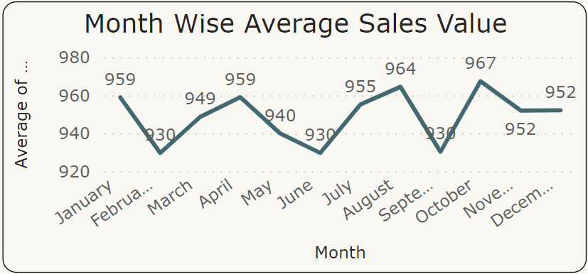

* From the above Line chart, we can see the Month wise sales in the company. As we observe the chart February, June and September sales are slightly less compared to other months. From enhanced promotional offers these months could benefit to boost sales.
* Targeted marketing strategies like Time limited sales, special discounts and incentives on that particular month could increase the sales. Go for more advertising on that particular month with the special deals.

1. **Identify which products may require increased marketing efforts. Which items have high prices yet underperform in sales?**

* 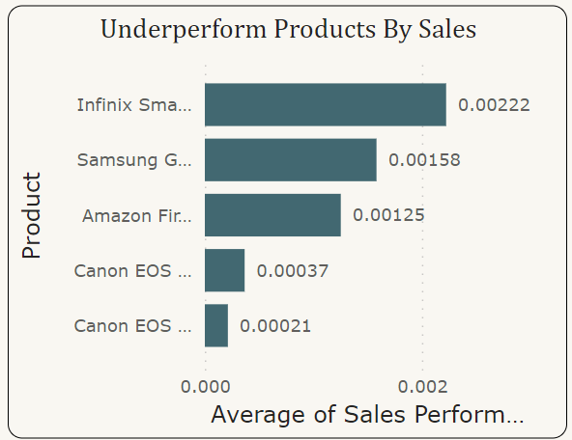
* From the above Bar chart, these are the 5 underperformed products which may require increased marketing efforts.
* First I calculated sales performance by using DAX formula “DIVIDE” i.e. **Sales Performance = DIVIDE(Orders[Order Quantity], Orders[Sale Price]).**
* With the average of sales performance against products by using Bar chart and using filters for lowest 5 products I got the results.
* Despite having high price, the sales of these products are very low.

1. **Assess which products should have discounts. How can targeted incentives drive sales and customer loyalty for specific products?**

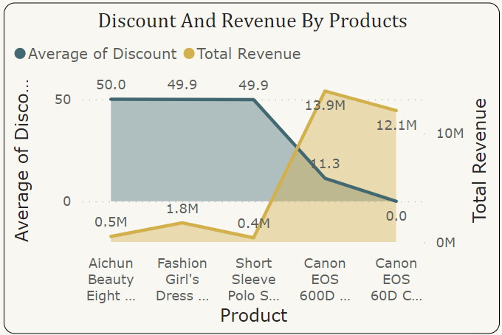

* As we see in the above Area chart, these are the products with lowest discounts. If we have more discounts for these products, we can drive more sales which will result in more revenue. I calculated discount for the products using **Discount = Orders[Cost Price] - Orders[Sale Price].** With average of discount in y- axis, total revenue in secondary axis and products in x-axis, we can see the

1. **Come up with a loyalty program to benefit the company’s customers. From the available lot of customers come up with strategies to bucket them and provide benefits under different loyalty programs.**

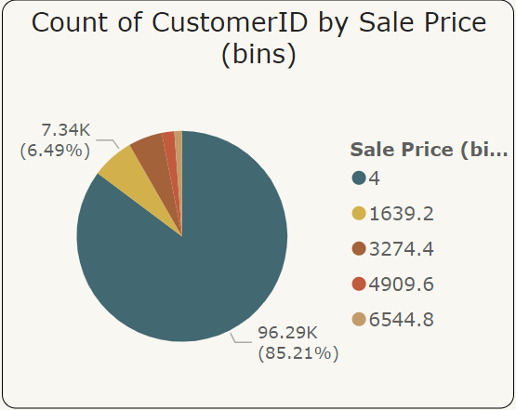

* I have grouped the customers into 5 categories based on the spending capacity.
* VIP Program for High End Customers - These customers are the highest spenders with minimum sale price of 6544.8. We can provide premium services tor these customers like early access to big sales.
* Reward Points Premium Customers - Premium customers minimum spending amount is 4909.6. Giving points on every spend will be a reward for their loyalty.
* Special Discounts for Standard Customers – Standard customers usual spend minimum of 3274.4. Giving rewards on special occasions like birthdays will make the customers happy.
* Card discounts for Economy Customers – Customers with minimum spending amount of 1639.2 are the economy customers. We can provide Card discounts for them if they pay money through their debit or credit cards.
* Cashback and High Discounts for Budget Friendly Customers – These customers mainly focus on their budget. If the sale price is less then only, they will purchase the products. So, giving cashback and high discounts will attract these customers.

1. **Using the DAX functions Calculate and a row iteration DAX function calculate the total sales for the Product Category “Fashion” and delivery type “Shipped from Abroad”. What are the other types of DAX functions you have used in the project?**

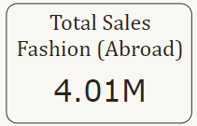

* The total sales for the Product Category "Fashion" and Delivery Type "Shipped from Abroad" is **4.01M**.
* The Other Types of DAX Functions Used are:
* **Aggregation Functions**: SUM, AVERAGE, COUNT
* **Filter Functions**: FILTER, ALL
* **Time Intelligence Functions**: DATEADD, TOTALYTD, SAMEPERIODLASTYEAR
* **Logical Functions**: IF, AND
* **Mathematical Functions:** DIVIDE, ABS
* **Statistical Functions:** RANKX
* **Iterative Functions:** SUMX, AVERAGEX
* **Information Functions**: ISBLANK

1. **Wait Times Correlated with Demographics and Care: Explore how average wait times vary across different product categories to optimize scheduling and staffing.**

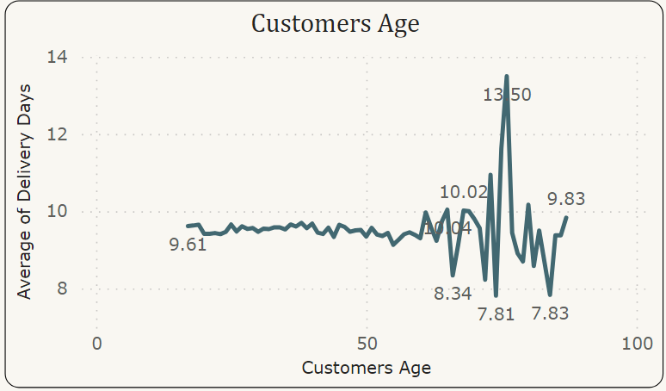

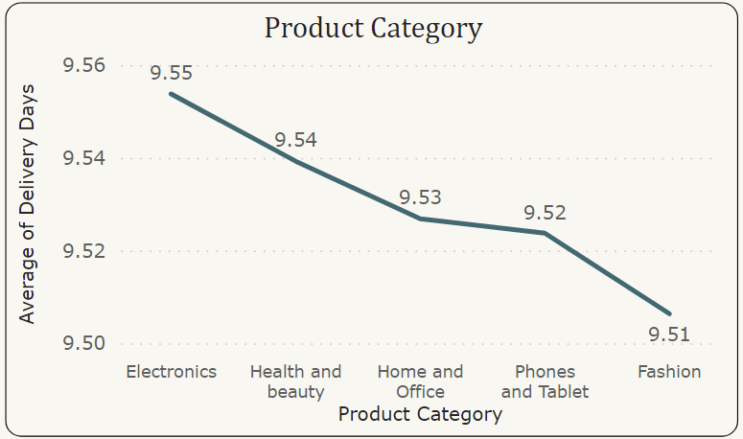

* Here Wait Time means Delivery Time from my dataset. In the first Line chart, we can see how wait time correlate with demographic i.e. Customer age. In the graph, above 60 years age group the average delivery time varies from 8.34 days to 13.50 days. Below 60 years there is no much variation in the average delivery time.
* In the second Line chart, we can see how average wait time vary across different product categories. For “Phones and Tablet” the average delivery time is 9.455 which is more compared to other product categories. We can do the scheduling and staffing accordingly.

1. **Explore if there is any relationship between the Delivery type and waiting time between ordering and receiving an item.**

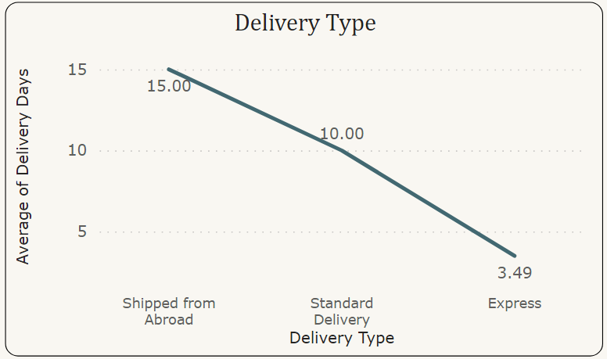

* As we can see in the above Line chart, there are mainly 3 different delivery types. Each delivery type has a different delivery time. Express delivery has an average of 3.49 days. Standard delivery type has an average of 10 days to deliver the product. Products from abroad will take more days to deliver.

1. I**s there any relationship between shipping charges and product type?**

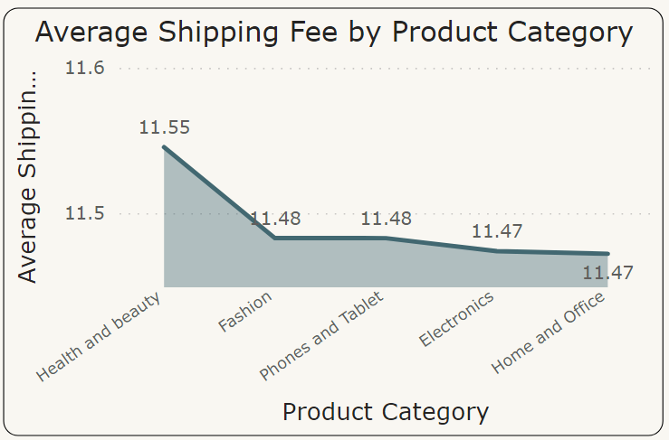

* By using Area chart with Product Category in X-axis and Average of Shipping fee in Y-axis, we can see the relationship between Shipping fee and product category. As we can see in the chart, Health and Beauty have high average shipping fee.

1. **Come up with strategies to decrease the low rating orders after analyzing different factors like waiting time, shipping type, unit price, etc.**

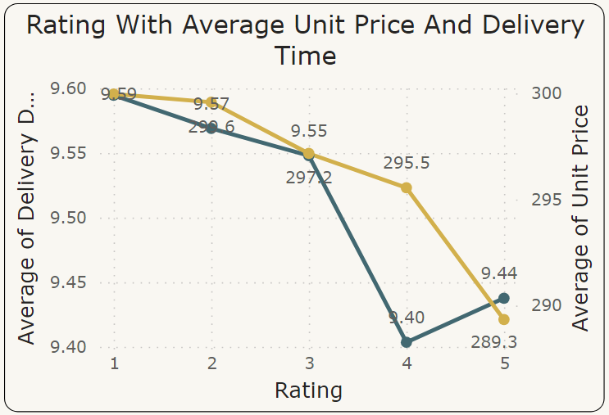

* To come up with different strategies to decrease the low rating orders, I have analyzed the waiting time, unit price for each rating.
* Here I used Line chart to display the waiting time and unit price for each rating.
* In the above chart, we can see for 5 rating the average delivery time and average unit price is low compared to other ratings.
* Strategies to decrease low rating orders:
* We can decrease the low rating orders by decreasing the delivery time. This can be done by offering them different delivery options like Express delivery, Standard delivery etc.
* By lowering the unit price, low rating orders can also be reduced.

1. **Using the time intelligence DAX function, create a table to compare each month’s sales with the previous year’s same month’s total sales. So there will be four columns in the output year, month, total sales, previous_years_sales.**

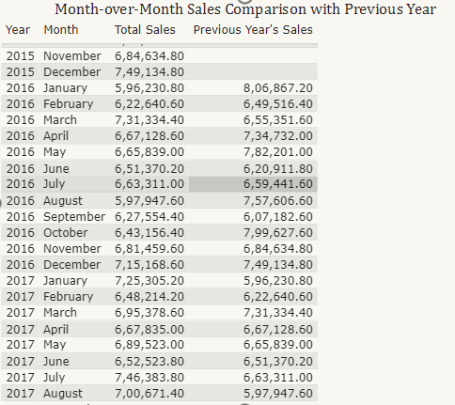

* **Objective:** Shows month-over-month comparisons to identify trends and growth.
* **Year and Month Columns:** Displays the year and month of sales data.
* **Total Sales:** Represents the total revenue generated for each month.
* **Previous Year's Sales:** Compares the same month's sales from the previous year**.**
* This helps analyze sales performance and year-over-year changes.

1. **What do you understand by PowerBI gateway? What are its use cases?**

* **Power BI Gateway:** A Power BI Gateway is a bridge that facilitates secure data transfer between on-premises data sources and Microsoft cloud services, such as Power BI, Power Apps, Power Automate, and Azure Logic Apps. It allows organizations to connect their local (on-premises) data to Power BI reports and dashboards in the cloud without moving the data.
* **Use Cases of Power BI Gateway:**
* **Data Refresh:** Automatically refresh on-premises data in Power BI.
* **Live Query**: Query on-premises data in real-time.
* **Hybrid Scenarios:** Connect cloud and on-premises data sources.
* **Secure Access:** Encrypt data transfer for security compliance.
* **Integration**: Link with Power Apps, Power Automate, and Azure Logic Apps.
* **Multi-Source Support**: Connect to various on-premises data sources (SQL Server, Oracle, etc.).

1. **How would you approach this problem, if the objective and subjective questions weren't given?**

* To approach the problem without predefined questions, I would:
* **Understand Data Structure**: Analyze tables (customers, orders), relationships, and key metrics.
* **Data Cleaning**: Handle missing values, correct data types, and remove duplicates.
* **Data Modeling**: Create relationships, design key DAX measures (e.g., total sales, revenue growth).
* **Analyze Insights**: Segment customers, analyze product/category performance, and revenue distribution.
* **Visualize Data**: Create dashboards for sales, customer insights, and product performance.
* **Scenario Analysis**: Identify low-performing products, suggest promotional strategies, and design loyalty programs.
* **Reporting**: Generate reports with actionable insights and strategic recommendations for improving sales and customer engagement.